
LITERACY AND ECONOMIC EMPOWEMENT OF PAKISTAN LOW INCOME URBAN YOUTH

Date : : 19th november ,2025
Presented to : Professor Sana Ullah Khan
Amina Falak | SP25-BED-012 | Data analysis & summary of study findings
Ammara Shahid | SP25-BED-014 | Recommendations
Amna Mahboob | SP25-BED-015 | Data cleaning & Data preprocessing
Anwar Ahmed | SP25-BED-016 | Compilation & formatting of document
Ashmal Imdad | SP25-BED-018 | Literature review: Past cases
Muhammad Awais | SP25-BED-019 | Proofreading & source verification
Muhammad Avaiz | SP25-BED-020 | Data visualization & data analysis
Ayman Imran | SP25-BED-021 | Introduction & Conclusion
Bushra Tariq | SP25-BED-024 | Executive summary
Azhar Mahmood | SP25-BED-022 | Literature review: Current cases
Presented by:

Contents
1.Executive Summary: 3
2.Introduction 4
Background Information 4
Purpose of the Report 4
Significance of the Study 4
Scope of the Study 5
Limitations of the Study 5
3.Literature Review 5
Past Examples of Pakistan Implementing Financial Literacy 5
State Bank of Pakistan (SBP) Financial Literacy Programme 6
Current Examples of Pakistan Implementing Financial Literacy 6
Youth-Specific Research & Gaps 6
4.Research methodology 6
Data source and collection 6
Data Restrictions and Limitations 7
Data Cleaning and Pre-Processing: 8
5.Finding 11
Descriptive Analysis 11
Correlation Analysis 14
6.Conclusion 15
7.Recommendations: 15
1.Add Financial Literacy Sessions in Universities: 15
2.Use Digital Platforms for Awareness: 15
3.Promote Practical Money Skills: 16
4.Partner With Banks and Fintechs: 16
5.Increase Community Outreach: 16
6. Support Youth Entrepreneurship: 16
8.References 17
9.Appendices 17

1.Executive Summary:
This report examines financial literacy and its influence on the economic empowerment of
low-income youth aged 20-25 in Islamabad, Pakistan. As financial systems become
increasingly digital and complex, young people face challenges while in budgeting, saving,
investing, and long-term planning. To assess financial knowledge and economic
empowerment levels, digital surveys using Google forms were conducted, mostly among
university students from middle- income families and limited timeframe created diversity
constraints. After comprehensive data cleaning, encoding, and scoring, the findings show
that most financial literacy scores indicated a basic understanding of money management but
limited knowledge of advanced concepts. This limits their confidence and independence to
make economic decisions. Literature review reveals past evaluation of programs
implemented in Pakistan, achieved short-term learning but lacked sustained behavioral
change due to minimal follow-up. The results indicate that many students manage basic
budgeting but face difficulty in dealing with interest rates, saving, and investing. Education
is moderately linked to financial literacy, and financial literacy and economic empowerment
have a very weak positive correlation. Overall, the findings stress the need for stronger and
more regular financial education. The report recommends integration of financial literacy in
education system, holding youth-focused campaigns like Denmark's "Money Week".

2.Introduction

Background Information
Financial literacy plays an important role in helping young people handle their day-to-day
expenses, plan for the future, and make responsible financial choices. In Pakistan, many
university students (especially those from low-income households) do not receive proper
guidance on money management. Because these students will soon enter the workforce and
shape the country’s economic future, their lack of financial awareness can create long-term
challenges. Poor budgeting habits, unnecessary borrowing, and a limited understanding of
savings or investment options show why strengthening financial literacy is essential for
preparing youth for economic participation.

Purpose of the Report
The purpose of this report is to assess the level of financial literacy among low-
income university students in Islamabad and examine how it influences their
economic empowerment. To guide the study, the following research questions were
developed:
- What key factors influence financial literacy and economic empowerment
among low-income urban youth in Pakistan ?
- How can youth be empowered economically to contribute more effectively
to national economic growth?

Significance of the Study
This study is important because it highlights where young people, particularly
those from low-income backgrounds, struggle with financial knowledge and
decision-making. By understanding these gaps, educators and policymakers can
design more effective financial education programs that genuinely meet students’
needs. The findings can also support government efforts to create policies that
encourage financial inclusion, improve access to financial services, and strengthen
youth participation in economic activities.

Scope of the Study
The study focuses on university students aged 20 to 25 from major universities in
Islamabad. It examines their financial knowledge, saving habits, budgeting
practices, and awareness of economic opportunities.

Limitations of the Study
The data for this study is based on approximately 80 survey responses due to time
constraints. While the findings provide useful insights, they may not fully
represent the financial literacy levels or economic empowerment of all low-income
urban youth in Pakistan.

3.Literature Review
This literature review looks at financial literacy programs in Pakistan, with a focus on
low-income urban youth aged 20–25 in Islamabad and this review also highlights past and
current programs to understand what actually supports youth empowerment.

Past Examples of Pakistan Implementing Financial Literacy

Khushhali Microfinance Bank
It was launched in 2000 and offered financial literacy alongside small loans. According to
Khan and Noreen (2012) the study shows that loans alone are not enough , people benefit
more when financial training is provided as well. However, because Khushhali mainly serves
older clients, its impact on young urban adults is limited.

Akhuwat
Provides interest free loans. According to research so far (e.g., Mubarik & Javed, 2019),
clients are becoming more confident in formal financial institutions and improving their
financial planning and small business startup.. However, micro-entrepreneurs continue to be
its main focus rather than young people joining urban labor markets..

State Bank of Pakistan (SBP) Financial Literacy Programme
By this programme , evaluations showed that people learned these skills in the short term,
but their long-term behavior did not change too much because the training was brief and there
was little follow-up (SBP, 2015–16).

Current Examples of Pakistan Implementing Financial Literacy

Karandaaz Pakistan focuses on digital financial literacy and youth engagement. Research
shows that many young people in Islamabad use mobile wallets, prefer app-based saving
tools, and are influenced by fintech platforms and social media influencers. Although
Karandaaz’s SME programs build digital skills, they only partly address youth needs such as
student loans, youth savings accounts, and basic budgeting.

Youth-Specific Research & Gaps
Research shows that Pakistani students have low financial literacy, and their money habits
are strongly influenced by family, media, and social networks. Key gaps remain in reaching
youth in Islamabad, who face rising education costs and limited financial products designed
for them .

4.Research methodology

Data source and collection
We held a digital survey using Google form to gather data for this study. The survey involved
three types of questions. Multiple choice question, testing financial knowledge, likert-scale
question, measuring economic empowerment levels, and demographic questions about
background information.

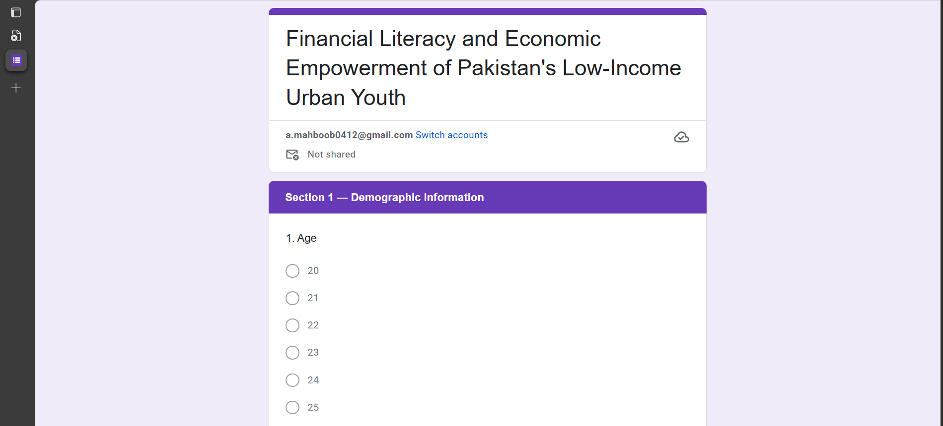
Figure 1 shows the google form where the survey was carried out for data collection

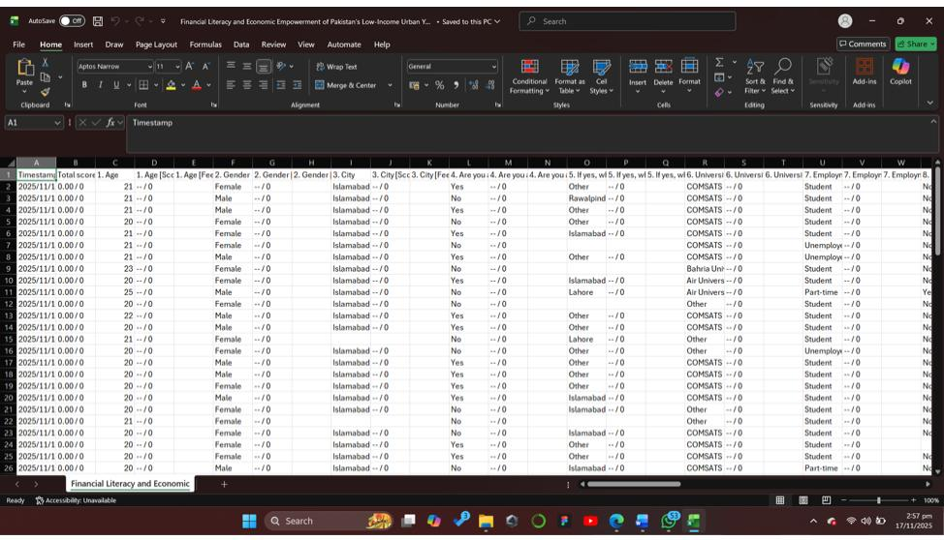
Figure 2 shows the dataset before cleaning

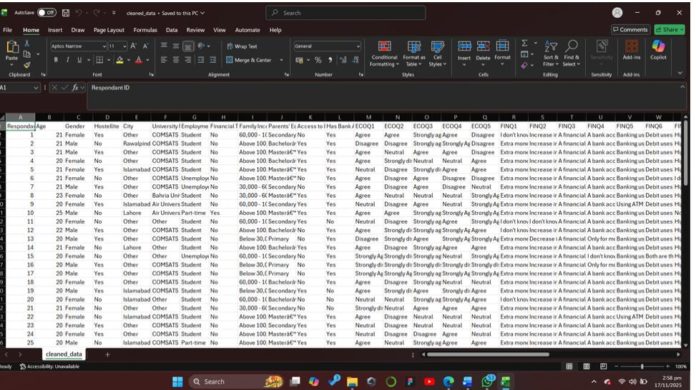
Figure 3 shows the dataset after cleaning

Data Restrictions and Limitations
Our report focused on youth aged 20–25 living in Islamabad. Most people who
participated in the survey were university students from middle-income backgrounds.
This created bias because most samples reached students through academic
networks, missing out on those who were not in universities. The limited time frame also
did not create much diversity in the samples.
These factors affected how broadly we can apply our findings to all young people in
Islamabad.

Data Cleaning and Pre-Processing:
We cleaned the data in several steps:
• Removed unnecessary columns in Excel.
• Renamed the columns for easier analysis and for use in a Python-based notebook.
• Removed null values and replaced them with mode values.
• Removed duplicate entries.
• Applied ordinal encoding and created two new columns for Financial Literacy and
• Converted responses to numerical codes for analysis.
• Created two new scores using the following formulas:
– Financial Literacy Score = (sum of correct answers / 8) × 10
– Economic Empowerment Score = (sum of empowerment scores / 25) × 10
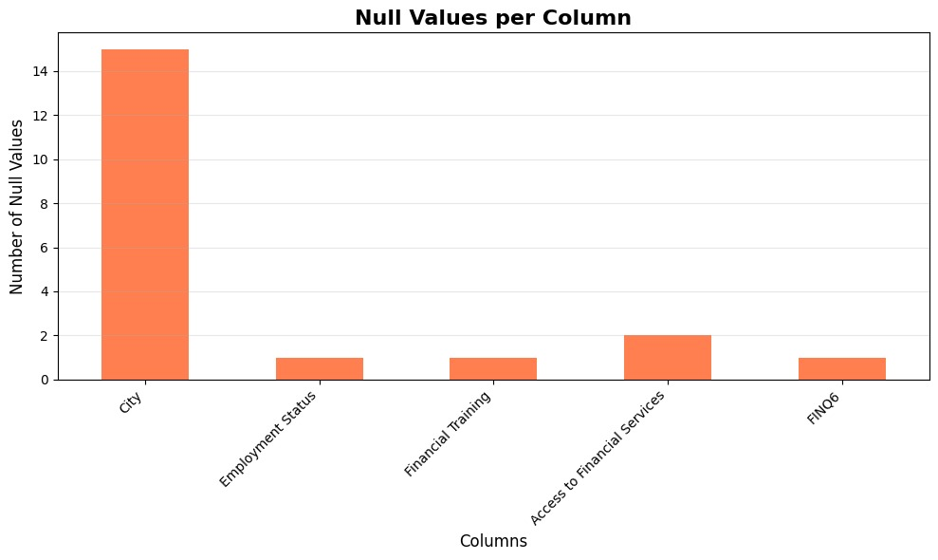
Figure 4 shows the null values present within the data set during cleaning

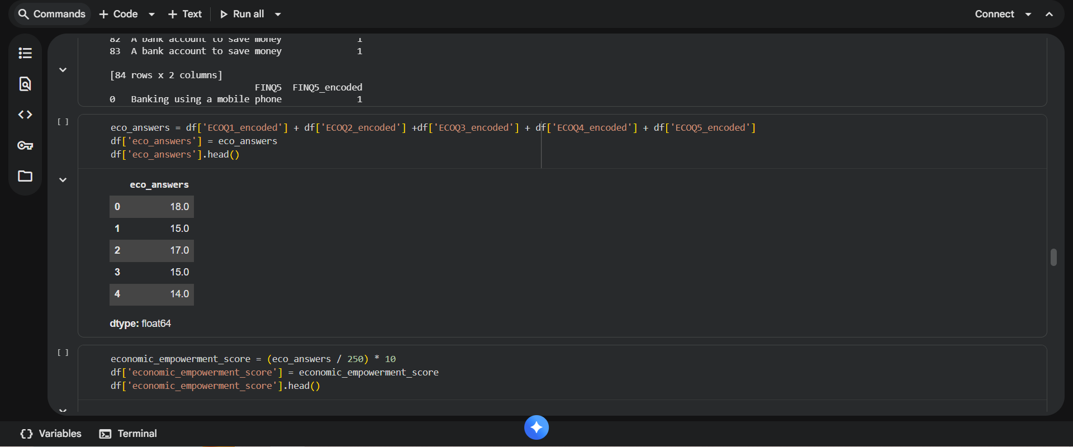
Figure 5 shows the python code in the google colab notebook using the economic empowerment score formula

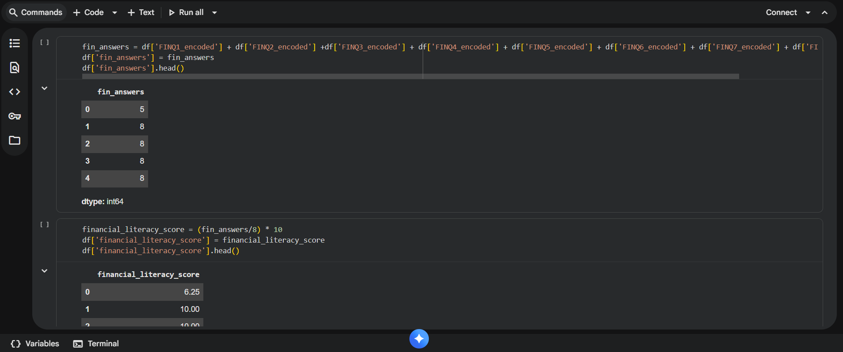
Figure 6 shows the python code in the google colab notebook using the financial literacy score formula

5.Finding

Descriptive Analysis
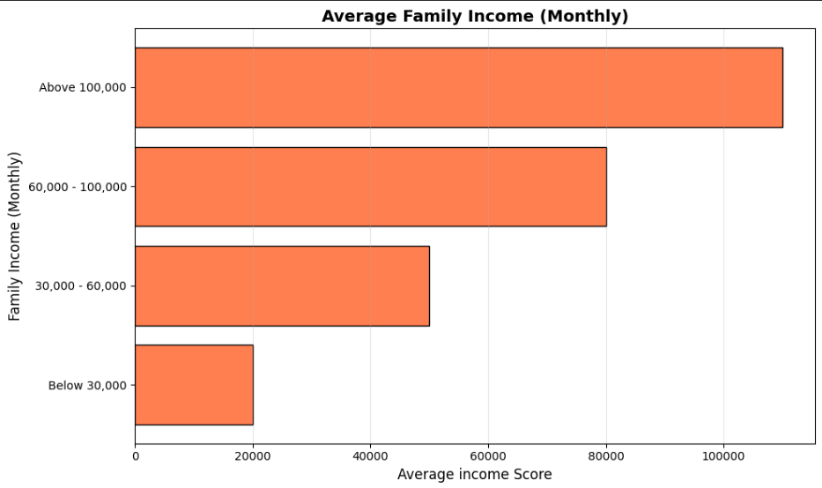
Figure 7 shows the graph of Average family income (monthly)

This graph shows subjects family income brackets. Most families fall in the middle-income
range (30,000-100,000 PKR monthly), matching with our target demographic. The least
represented groups are the highest and lowest income brackets, validating our focus on low to
middle-income urban youth.
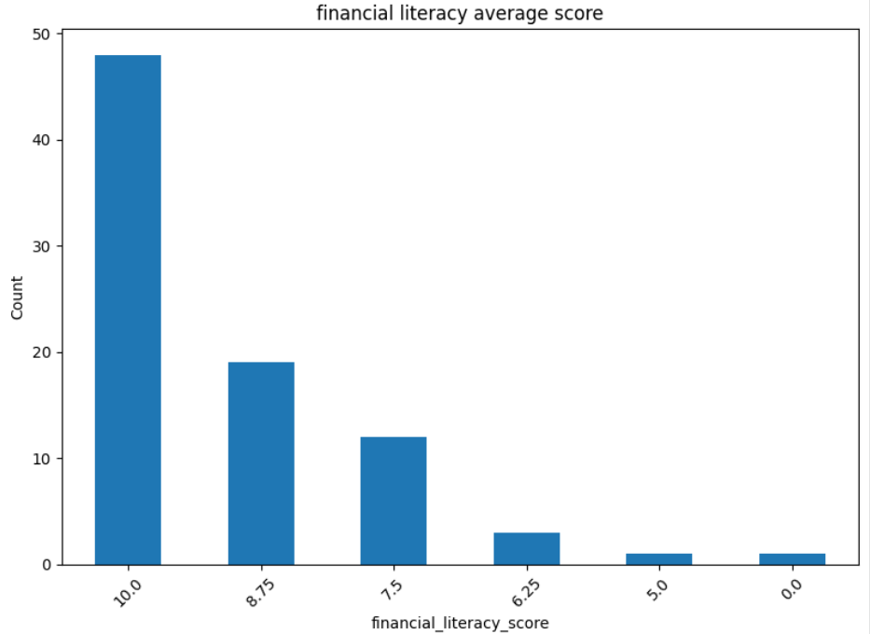
Figure 8 shows the graph of Financial Literacy Score Distribution

This graph shows the pattern of financial literacy scores among subjects. Majority respondents scored in the medium range (4-6 out of 8), showing a basic understanding of financial concepts.The least number of subjects achieved either very high or very low scores, showing consistent average knowledge levels across the sample

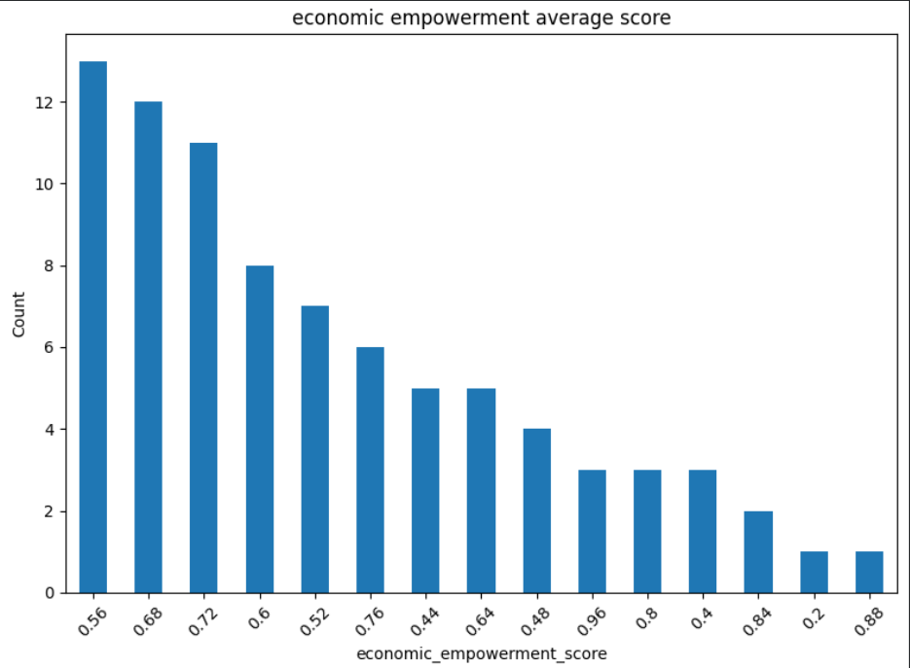
Figure 9 shows the graph of the average score for the economic empowerment score

This graph show how economic empowerment scores are arranged. Most subjects show average empowerment levels (6-7 out of 10), showing they feel partially in control of their financial decisions. The least common were extreme high or low empowerment scores, indicating generally parallel perceptions of economic agency.

Correlation Analysis
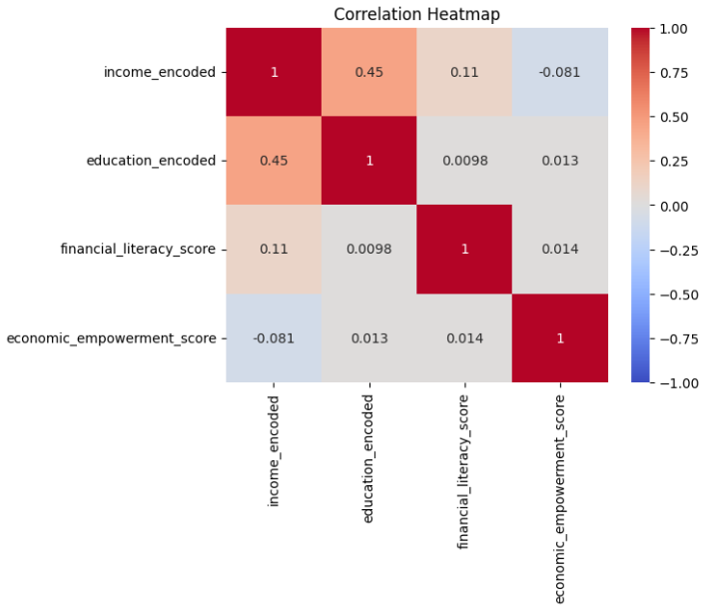
Figure 10 shows the graph of Correlation Heatmap of Key Variables (income, education, financial literacy score and economic empowerment score)

The heatmap show relationships among financial literacy score, income, education, and
economic empowerment.
Education & Financial Literacy: Positive correlation (0.45) higher education lead to better
financial knowledge
Income & Economic Empowerment: Weak positive correlation (0.081) family income feel
slightly influences empowerment
Financial Literacy & Economic Empowerment: Very weak positive correlation (0.014) financial
knowledge alone has very small impact on empowerment.
Note: These correlations explained because because to the limited sample size and potential
sampling bias

6.Conclusion
The study demonstrates that although many low-income university students in Islamabad
possess basic budgeting habits, significant gaps remain in their understanding of deeper
financial concepts such as investing, interest rates, and long-term planning. The survey
findings (drawn from a modest sample size) show that limited financial knowledge restricts
students’ confidence , decision-making abilities, and overall economic empowerment. These
results align with earlier case studies in Pakistan, which reveal that financial literacy efforts
are most effective when they are continuous, youth-focused, and supported by accessible
financial services. Given these findings, Pakistan can benefit from adopting structured
approaches similar to successful international models. Overall, the evidence highlights the
urgent need for structured, long- term financial education strategies. In light of these
insights, the following recommendations aim to address the key weaknesses identified
through this research.

7.Recommendations:
Recommendations to Improve Financial Literacy Among Students in Islamabad
Based on the results showing mostly average financial literacy and empowerment levels, the
following steps can help strengthen financial understanding among youth:

1.Add Financial Literacy Sessions in Universities:
Offer short courses, workshops, and seminars on budgeting, saving, and basic investing.

2.Use Digital Platforms for Awareness:
Share simple financial tips through social media, short videos, and mobile-friendly guides.

3.Promote Practical Money Skills:
Encourage students to track expenses, join budgeting challenges, or use financial apps.

4.Partner With Banks and Fintechs:
Organizing on campus awareness drives on digital banking, saving accounts, and smart money habits.

5.Increase Community Outreach:
Hold financial education sessions in community centers to reach youth outside universities.

6. Support Youth Entrepreneurship:
Provide basic training on starting small businesses to build confidence and financial independence.

Examples of Foreign Country Policies to Drive Economic Empowerment
Denmark proposed an annual financial education week in Denmark, organized by
finance Denmark along with partners like the Danish National Bank and math’s
Teachers Association. “Danish Money Week”.
Denmark teaches teenagers (ages 13–15) foundational financial concepts such as
budgeting, saving, and investment risks through its nationwide Danish Money Week
program. Starting early enables youth to make informed choices about their financial futures

Pakistan can further enhance youth financial literacy through following up foreign policies:
- Add Financial Literacy to Schools
- Create “Financial Navi Pakistan”
- Launch National Youth Campaigns
- Use Mobile Tech for Wider Reach
- Expand Community Learning

8.References

- Ali, M., Alamgir, M., & Nawaz, M. A. (2024). Digital financial literacy and student financial behavior in Pakistan. Pakistan Social Sciences Review, 8(2), 141–155. https://www.ojs.pssr.org.pk/journal/article/view/525
- Qamar, A., Rasheed, N., Kamal, A., Rauf, S., & Nizam, K. (2023). Financial behavior of millennials in Pakistan: Role of digital literacy. International Journal of Social Science & Entrepreneurship, 3(3), 330–352. https://ijsse.salmaedusociety.com/index.php/ijsse/article/view/207
- Mubarik, M. S., & Javed, S. (2019). Impact assessment of Akhuwat microfinance model in Pakistan. Journal of Islamic Finance, 8(1), 45–57. https://www.akhuwat.org.pk/impact-assessment-2010/
- Khan, A. G., & Noreen, U. (2012). Microfinance and women’s empowerment: A case study of Khushhali Bank Pakistan. International Journal of Business and Social Science, 3(22), 99–107.
- World Economic Forum. (2023). Denmark teaches its teens about financial literacy through “Money Week”. https://www.weforum.org/videos/denmark-teens-financial-literacy/
- Federal Ministry of Finance, & Oesterreichische Nationalbank. (2021). Finanznavi: About us. https://finanznavi.gv.at/en/about-us

- Amna, M. (2025). FinancialLiteracyPakistan.ipynb [Jupyter notebook]. Google Colab. https://colab.research.google.com/drive/1vwZKHX27ZaMRPOY_0Oj19mcJ73Aw6P5f?usp=sharing

9.Appendices
Figure 1 shows the dataset before cleaning 7
Figure 2 shows the dataset after cleaning 7
Figure 3 shows the null values present within the data set during cleaning 9
Figure 4 shows the python code in the google colab notebook using the economic empowerment score formula 9
Figure 5 shows the python code in the google colab notebook using the financial literacy score formula 10
Figure 6 shows the graph of Average family income (monthly) 11
Figure 7 shows the graph of Financial Literacy Score Distribution 12
Figure 8 shows the graph of the average score for the economic empowerment score 13
Figure 9 shows the graph of Correlation Heatmap of Key Variables (income, education, financial literacy score and economic empowerment score) 14

